Within the sixth European Commission framework programme, the main objective of the SEAT project initiated in September, 2006, consists of the development of a radically new concept, where the aircraft passenger comfort is considered at the highest level. Smart reactive seats and an interior environment able to detect on real time physiological and psychological changes in the passenger conditions will be developed. These data will be analysed and the appropriate parameters, like noise and vibration levels, temperature or air ventilation, will be adapted. Moreover, each passenger will be able to create his own configuration, with his personal entertainment and work characteristics. The project is focussed on the questions previous to the integration of the system, that is above all the creation of a more healthy and comfortable travel environment by means of noise and vibration reduction, as well as specific climatic controls. In this paper, the first passive and active designs under development are presented.

- Introduction
In aircrafts and all means of transport in general, the comfort of passengers is clearly a important factor in the acceptance and user satisfaction. In a vehicle, the reaction of a person depends not only on the physical factors, but also the characteristics of the individual. Research on number of passengers and comfort indicate that there is no optimal configuration for aircrafts and also the satisfaction requirements are usually conflicting, as the perception of comfort is affected by several factors such as gender or the customs. This project promotes a radically new concept in the sense that the overall approach is creating an environment that satisfies the requirements and individual desires, and is not centrally controlled or manually adjusted. The system is based on advanced technologies; a prototype is to be demonstrated to the public at the end of the project (at the end of 2009).

These requirements come from the fact that travel has become a global activity that is not confined on any geographic area, social or ethnic group. Consequently, airlines need to respond frequently to contradictory requirements in a centrally controlled environment; the approach of "lowest common denominator" is the only viable. This policy is commonly implemented at the lowest price, while the market normally opts for more services and features that would satisfy the usually more demanding customers.

However, the current thinking is focused on the travelling basic requirements but do not necessarily address the contextual needs, require a lot of space and many of its costly facilities are rarely used. Users have very little time to study different features and are frequently reluctant to do so. Hence it is important that such features are not manually controlled but are part of an integrated system that adapts to the passenger’s needs.

The project is focused on:
- development of a system for active/passive vibration dampening incorporating smart textiles;
- Creation of a “smart seat” that adapts the climatic characteristic to the passenger physiological status;
- integrated physiological monitoring system with health alert options;
- development of interactive entertainment; and
- development of fully integrated cabin passenger services.

The main SEAT objectives could be defined as follows:
- To develop a system that suppresses noise overall, as well as for each passenger.
- To develop novel approach to active/passive vibration reduction incorporating smart technologies and textiles in particular.
- To develop technology allowing healthier cabin environment including temperature, pressure, airflow and humidity.
- To develop on-board systems that will enable office-like and home-like services.
- To develop a functional prototype of the “SEAT” system that will be an important stage of a development of e-cabin.
- Participant List
Thales | Leader of task  Main end-user and informant about the possibilities of production and compatibility of the development of integrated system design
INSITITUTO TECNOLOGICO DEL CALZADO Y CONEXAS | Design and development of sensors and monitoring system
Asociación de Investigación de la Industria Textil | Leader of task  Development of intelligent seat  Development of intelligent textiles based on noise and vibration damping
Imperial College London | Overall coordination of project  Modeling of active deadening of noise and vibration
Technische Universiteit Eindhoven | Leader of task  Development of interactive entertainment system “based on the context”
Eidgenoessische Technische Hochschule Zuerich | Development of physiological monitoring system  Integration of portable system on SEAT system
Czech Technical University | Control of temperature and humidity for each passenger  Individual control of the comfort, based on these conditions
Queen Mary and Westfield College | Leader of task  Development of a physiological model
Antecuir S.L. | Desarrollo de alfombras y tapicerías inteligentes  Development of carpets and intelligent upholstery
Acústica y Telecomunicaciones, S.L | Leader of task  Development of measurements, noise and vibration simulations, establishment of nuisance model and defining appropriate systems of active control
StarLab | Hardware design of integrated system
Design Hosting Software Ltd. | Analysis of utility and small design of interface screens

- State of the art on active control of noise and vibration
Comfort is a dynamic role multidimensional several independent variables. In addition, the criterion of quality associated with comfort is not unique, but is affected by perceptions, viewpoints and customs subjective. However, some features representative of the majority of physiological factors are measurable and objective evaluation is possible. Clearly, the effect of noise and vibration is one of these factors.

There are several causes of vibration on an airplane, as the extension and retraction of landing gear, the deployment of the aerodynamic brakes, the free movement of the movable surfaces and malfunctions of some systems. Some vibrations are constantly present and its effect could be minimized through appropriate designs, but others may develop due to temporary failures or abnormal situations. Such vibrations could be treated through active control if appropriate systems were installed [4][5]. Important vibrations are not only those affecting our perception of comfort, but also those who came into resonance with the natural frequencies of the different body parts, between 2 and 10 Hz.

So far, the vibrations have been reduced by means of specially designed panels or systems which act on the aircraft structure, but there are no documented results on comfort and relaxation at the passenger. Passive attenuators as natural carpets do not seem to have been used and intelligent multilayer panels have been used as a secondary source for the active control of aircraft noise in [6][7].

Also active noise control, using loudspeakers located in the cabin to control the sources, has proven to be an efficient method. The typical noise control systems can be implemented to control sounds generated by a combination of turbulent sources. In this case, active structural acoustic control, that uses direct action on radiation sources to reduce their noise, will not be used.

However, the control of the noise attenuation remains a complicated issue and it is very difficult to obtain reductions in the whole range of frequencies. These are some of the drawbacks associated with the method of active noise control. On the other hand, the use of passive or viscoelastic and/or porous materials may be appropriate to reduce the radiation noise, although this technique is not very effective at low frequencies. The combination of these active and passive techniques, by means of hybrid devices development, allows controlling the noise over the entire frequency range. Indeed, in recent years the hybrid techniques to control noise and vibration have been increasing. The passive device performs the first attenuation, while the active components usually improve the limitations of the passive method.
- Attenuation of noise and vibration
The modern aircraft are very stable and quieter than their predecessors, but noise continues to be one of the most irritating factors for passengers. The noise comes from three main sources: engine, plane vibrations, other passengers (crying children, movements, music, ...). These noises can not be avoided and also, the tolerance level of people depending on their age, their character, their state of health. Therefore, the active noise control personalized is an appropriate strategy. This strategy has two main aspects: global and local attenuation of noise and vibrations through intelligent technologies. The basis of this strategy is showed below.

The vibrations affect the overall state of people, such as fatigue, which is one of the greatest causes of stress. The vibrations also depend on the characteristics of different parts of the body. The use of appropriate smart textiles materials on upholstery, wall covering, carpets, etc.. could solve the problem.
The importance of this project resides in the integrated system, so that it is essential that the developed technology can be capable of working independently. It is possible to achieve this objective through the approach proposed, which seek to mitigate passive / active and the reducing noise.

More specifically, the following tasks will be performed:
- State of the art (more detailed than the previous one)
- Definition of an environment and acoustically 'vibrating' appropriate,
- Passive control design system,
- Active control design system,
- Design and characterization of the prototype,
- Integrity of the prototype in complete environment.

- Results
The Figure 1 shows the vibratory simulation of seat (half of geometry) by means of FEA (Finite Element Analysis), the maxima deformations on this example (84 Hz) occur on the back of seat and the head of passenger.

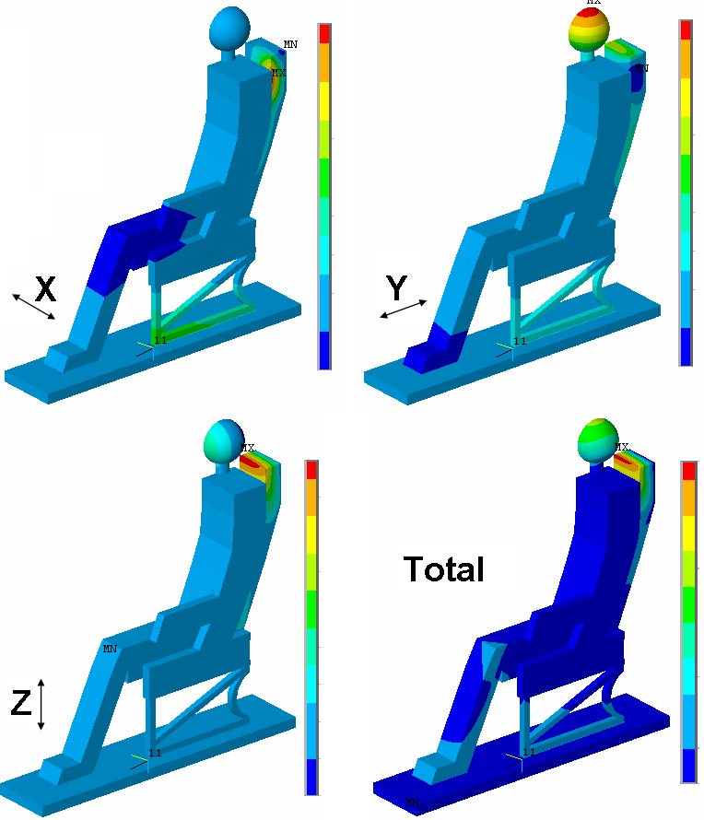
- Figure 1 FEM for vibrations simulations

The Figure 2 shows the noise simulation inside the plane cabin mock-up by means of BEM (Boundary Elements Method). The results allow the strategic location of sensors for active noise control.
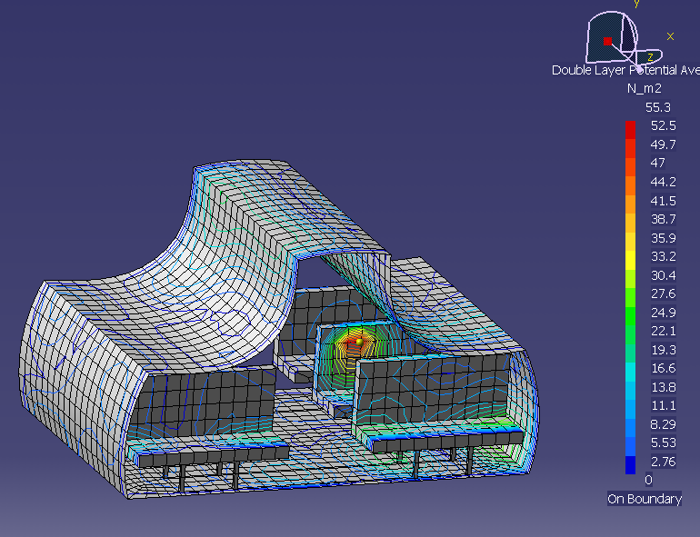
- Figure 2 BEM for noise simulations

The Figure 3 shows the mock-up used for experimental tests (right) and the contours of its noise level (left), the testing. On this example the source of noise is located at the bottom of the cabin.

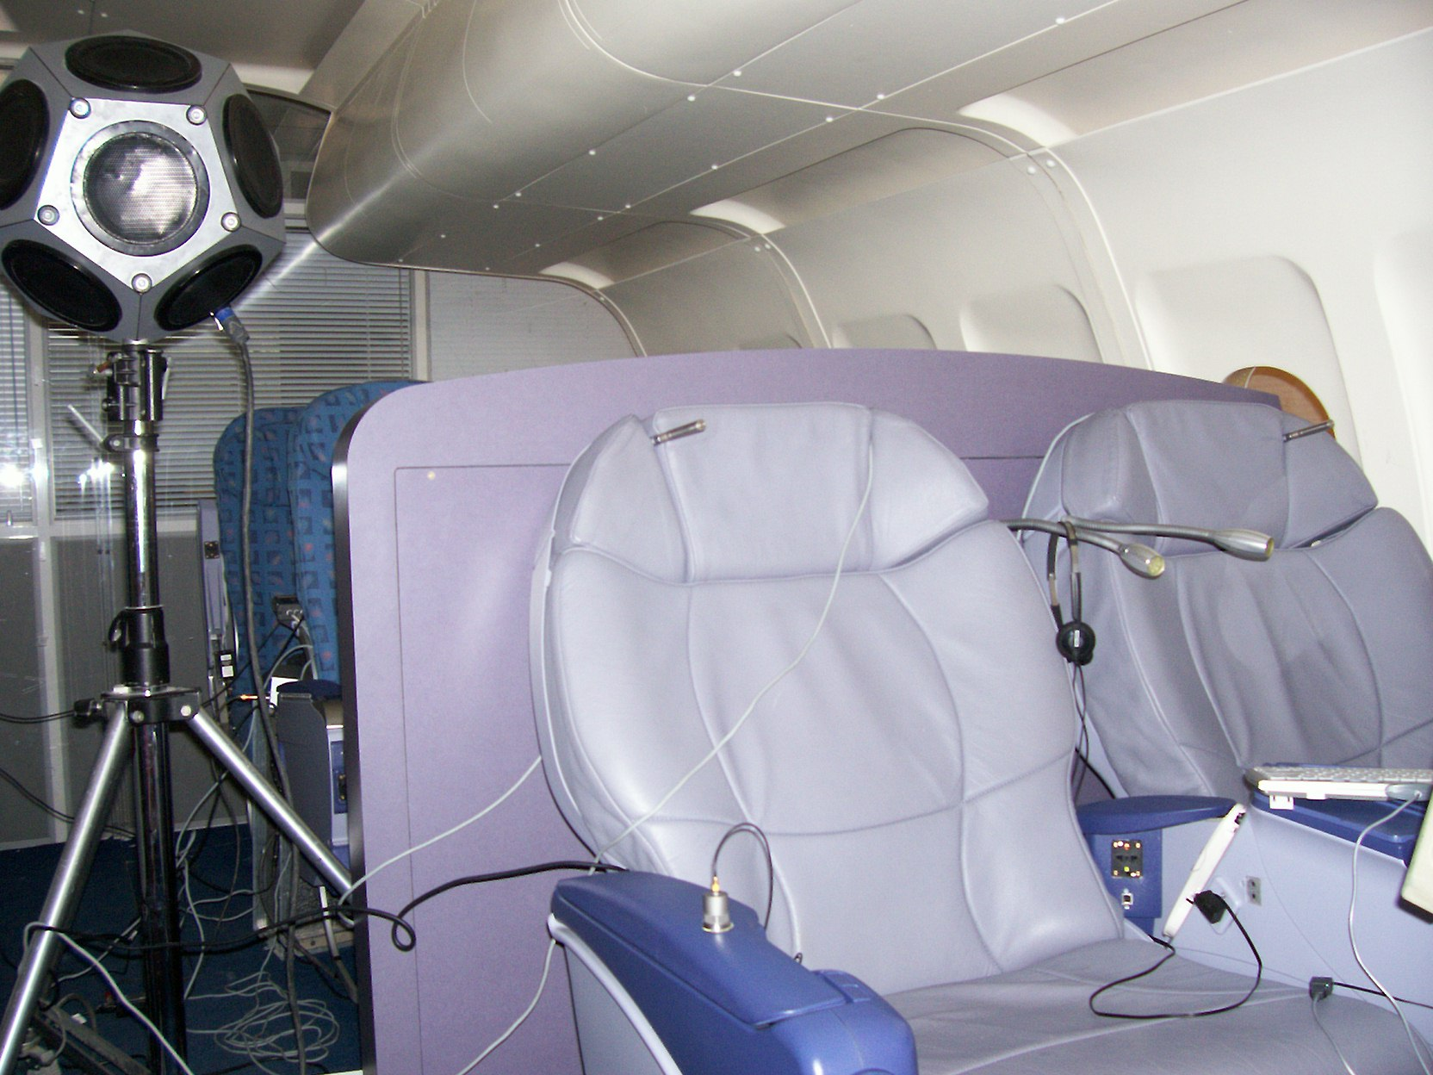

- Figure 3 Mock-up for noise tests

- Conclusion
Boeing has a seat version with similar characteristics, MiniPod ®, which is now available to users of class' business' in the Boeing 777-200LR, the world's largest aircraft. Furthermore, this apparatus has the latest technologies and options. This seat has also been chosen by 15 first-class companies like: Japan Airlines, Northwest Airlines, Qantas Airways, Air France, Korean Airlines, China Southern, China Eastern, Thai Airways or Malaysia Airlines, and will also be consider for the Airbus A330. That shows the importance of improvements in interior design and in addition, these services are easily transferable to all kinds of transport and their individual characteristics could also become part of personal and professional environment.

Acknowledgments
This project is sponsored by the European Commission DG H.3 Research, Aeronautics Unit under the 6th Framework Programme under contract Number: AST5-CT-2006-030958.

References
[1] Cobo Parra P, “Control activo del ruido. Principios y aplicaciones”, CSIC, 1997
[2] Nelson PA, Elliot SJ, “Active control of sound ISVR”, Southampton, UK
[3] David P, Collet M, Bethillier M, “Active acoustical skin using distributed electro-dynamical transducer”, Euronoise Tampere 2006
[4] Konstanzer P, Gruenewald M, Jaenker P, Storm S, “Piezo tunable vibration absorber system for aircraft interior noise reduction”, Euronoise Tampere 2006
[5] Aoki Y, Gardonio P, Stephen J, “Stability of a piezolelectric patch-accelerometer active damping control system in smart panel”, Euronoise Tampere 2006
[6] Bonnot M, Romeu J, Capdevila R, Sánchez A, “Aplicación del control activo a la reducción del ruido en la cabina de un avión ligero”, Tecniacustica Terrassa 2005
[7] Tewes S, Maier R, Peiffer A, “Active control of sound transmission through aircraft structures – modelling and system design”, Euronoise Tampere 2006

